

**TV ONLINE SHOP PROJECT**

**Software Design Specification**

**Group 1**

– Hanoi, August 2022 –

Record of changeS

|  |  |  |  |
| --- | --- | --- | --- |
| Date | A* M, D | In charge | Change Description |
| 03/01 | M |  | Choose Topic Online TV Shop. |
| 09/01 | M |  | Create plan for single iteration and milestone, goal for single iteration. |
| 12/01 | M |  | Create Database |
| 18/01 | M |  | Fix Database |
| 03/02 | M |  | Fix Database |
| 03/02 | M |  | Create SRS Documentary |
| 07/02 | M |  | Find and create template |
| 08/02 | M |  | Learning Using git to push code |
| 10/02 | M |  | Code Login and logout feature |
| 13/02 | M |  | Code CRUD of user |
| 13/02 | M |  | Code UserProfile |
| 13/02 | M |  | Add document to SRS documentary |
| 17/02 | A |  | Code Home Page |
| 21/02 | A |  | Create SDS documentary |

*A - Added M - Modified D - Deleted

**Table of Contents**

I. Overview 3

1. Code Packages 3

2. Database Design 4

a. Database Schema 4

b. Table Description 5

II. Code Designs 6

1. Login 6

a. Class Diagram 6

d. Database queries 7

2. Sign up 7

a. Class Diagram 7

b. Class Specifications 7

Class 1 : Register control 7

c. Database queries 7

3. Home 8

a. Class Diagram 8

b. Class Specifications 8

c. Database queries 8

4. TV Detail 8

a. Class Diagram 8

b. Class Specifications 8

c. Sequence Diagram 8

d. Database queries 8

5. User Profile 8

a. Class Diagram 8

b. Class Specifications 8

6. Change Password 9

a. Class Diagram 9

b. Class Specifications 9

c. Sequence Diagram 9

d. Database queries 10

7. Change Profile 10

a. Class Diagram 10

b. Class Specifications 10

c. Sequence Diagram 11

d. Database queries 11

# I. Overview

## 1. Code Packages

[Provide the package diagram for each sub-system. The content of this section including the overall package diagram, the explanation, package and class naming conventions in each package. Please see the sample and description table format below – following Java project naming convention]

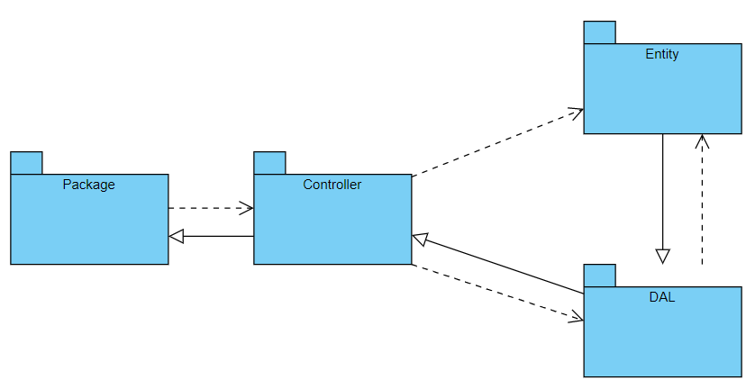

### a.Package descriptions & package class naming conventions

|  |  |  |
| --- | --- | --- |
| **No** | **Package** | **Description** |
| 01 | DAL | This package contain SQL query to push to severlet. |
| 02 | connectDB | this package is to connect with database |
| 03 | Controller | This package is to manage severlet. Get data, process data and control the pages. |
| 04 | Entity | This package have entities for tables in database and have properties the same with tables in database |

## 2. Database Design

### a. Database Schema

[Provide the tables relationship like example below – following SQL server database naming convention]

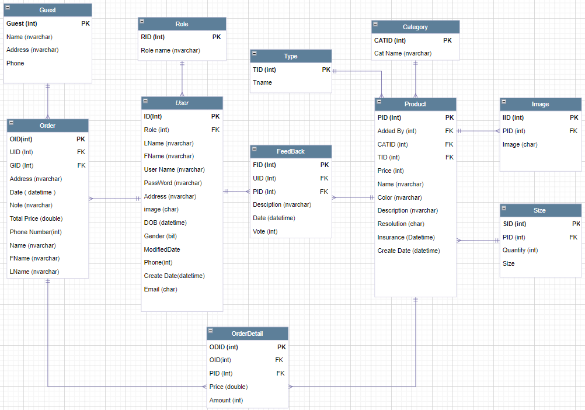

### b. Table Description

|  |  |  |
| --- | --- | --- |
| **No** | **Table** | **Description** |
| 01 | Guest | Show properties of guest in database to upload data from SQL |
| 02 | Role | Show properties of role in database to upload data from SQL |
| 03 | Order | Show properties of order in database to upload data from SQL |
| 04 | User | Show properties of user in database to upload data from SQL |
| 05 | OrderDetail | Show properties of order detail in database to upload data from SQL |
| 06 | FeedBack | Show properties of feed back in database to upload data from SQL |
| 07 | Type | Show properties of type in database to upload data from SQL |
| 08 | Category | Show properties of category in database to upload data from SQL |
| 09 | Product | Show properties of product in database to upload data from SQL |
| 10 | Image | Show properties of image in database to upload data from SQL |
| 11 | Size | Show properties of size in database to upload data from SQL |

# II. Code Designs

## 1. Login

### a. Class Diagram

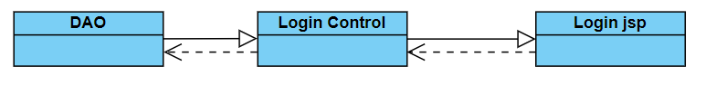**b. Class Specifications**

#### Class 1 : DAO

|  |  |  |
| --- | --- | --- |
| **No** | **Method** | **Description** |
| 01 | Login | This method will take user name + password information of user inputted to return account. |

#### Class 2 : LoginControl

|  |  |  |
| --- | --- | --- |
| **No** | **Method** | **Description** |
| 01 | Login | Login this method will use to call dao login method. |

**c. Sequence Diagram(s)**

### d. Database queries

## **"Select * from [User] where [username] =?\n"**

## **+ " and [password] =?"**

## 2. Sign up

### a. Class Diagram

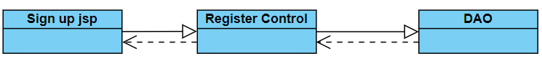

### b. Class Specifications

### Class 1 : Register control

|  |  |  |
| --- | --- | --- |
| **No** | **Method** | **Description** |
| 01 | existedUser | This method will check if username existed or not , if existed return sign up.jsp. |
| 02 | register | This method take all information of user sign up inputted to database. |

#### Class 2 : DAO

|  |  |  |
| --- | --- | --- |
| **No** | **Method** | **Description** |
| 01 | register | This method will take all user information inputted to database. |

### c. Database queries

**"INSERT INTO [dbo].[User]\n"**

**+ " ([Role]\n"**

**+ " ,[FName]\n"**

**+ " ,[UserName]\n"**

**+ " ,[PassWord]\n"**

**+ " ,[Phone]\n"**

**+ " ,[CreatedDate]\n"**

**+ " ,[ModifiedDate])\n"**

**+ " VALUES (?,?,?,?,?,?,?)"**

### Sign up - Google

### a. Class Diagram

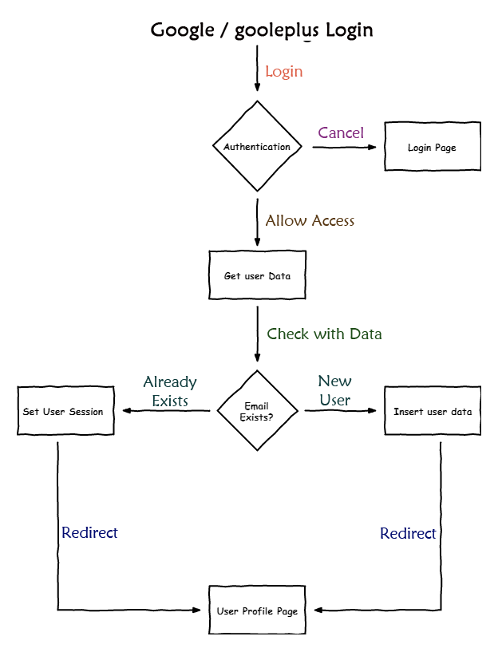

### b. Class Specifications

#### Class 1 : LoginGoogleHandler

|  |  |  |
| --- | --- | --- |
| **No** | **Method** | **Description** |
| 01 | getToken | This method will take a code of google to send again google to get access token |
| 02 | getUserInfo | This method take all information of user form a access token |

## 4. Home

### a. Class Diagram

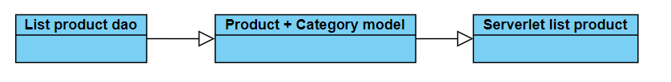

### b. Class Specifications

#### Class 1 : DAO

|  |  |  |
| --- | --- | --- |
| **No** | **Method** | **Description** |
| 01 | GetAlltype | This method take type by product id in database. |
| 02 | Get all image by id | This method take all image by product id in database. |
| 03 | Getcategory by id | This method take category by product id in database. |

### c. Database queries

**"select * from Type" get all type**

**"select * from Type where TID = ?" get type by id**

**"select * from category where CATID = ?" get category by id**

**"select * from Image where PID = ? "get all image by id**

### 5. TV Detail

### a. Class Diagram

### b. Class Specifications

### c. Sequence Diagram

### d. Database queries

## 6. User Profile

### a. Class Diagram

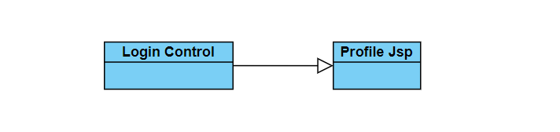

### b. Class Specifications

|  |  |  |
| --- | --- | --- |
| **No** | **Method** | **Description** |
| 01 | sessionscope.acc.lname | this medthod will take last name from session of user |
| 02 | sessionscope.acc.fname | This method will take first name form session of user. |
| 03 | sessionscope.acc.dob | This method will take dob form session of user. |
| 04 | sessionscope.acc.gender | This method will take gender form session of user. |
| 05 | sessionscope.acc.email | This method will take email form session of user. |
| 06 | sessionscope.acc.phone | This method will take phone form session of user. |
| 07 | sessionscope.acc.address | This method will take address form session of user. |
| 08 | sessionscope.acc.image | This method will take image form session of user. |

## **7. Change Password**

### a. Class Diagram

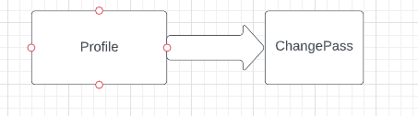

### b. Class Specifications

|  |  |  |
| --- | --- | --- |
| No | Method | Description |
| 1 | (User)session.getAttribute("acc"); | This method will take session of user when login |
| 2 | changePass | This method will change password of user in database |

### c. Sequence Diagram

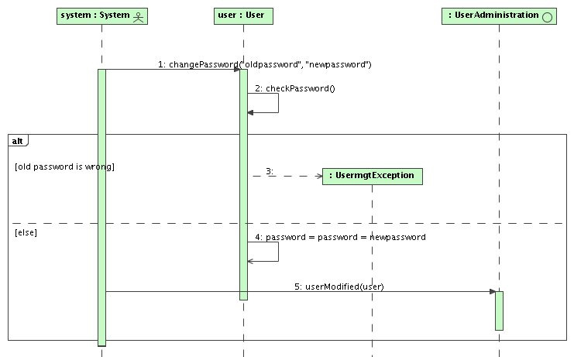

### d. Database queries

update [User] set PassWord = ? where [UserName] = ?

## 8. Change Profile

### a. Class Diagram

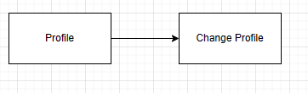

### b. Class Specifications

|  |  |  |
| --- | --- | --- |
| No | Method | Description |
| 1 | CheckUsUid(uid) | This method will check user exits or not |
| 2 | Changeprofile(lname, fname, address, image, dob, gen, phone, email, format, uid) | This method will change information user in database |

### c. Sequence Diagram

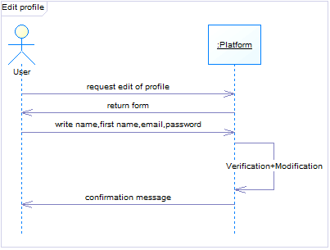

### d. Database queries

Select * from [User] where [ID] =?

UPDATE [dbo].[User]\n"

+ " SET [LName] = ?"

+ " ,[FName] = ?"

+ " ,[Address] = ?"

+ " ,[image] = ? "

+ " ,[DOB] = ? "

+ " ,[Gender] = ? "

+ " ,[Phone] = ? "

+ " ,[Email] = ? "

+ " ,[ModifiedDate] = ?"

+ " WHERE [ID] = ? "